Next Appointment is:  DAY DATE TIME WITH  _____________________________________________________________________________________________  _____________________________________________________________________________________________  _____________________________________________________________________________________________  _____________________________________________________________________________________________  _____________________________________________________________________________________________  _____________________________________________________________________________________________  Galway Medical Centre  267 Marion Road  MARLESTON SA 5033  Tel (work): (08) 8351 2211 |  |  | Asthma Cycle of Care  galway medical centre

What is a peak expiratory flow rate test?  The peak expiratory flow rate (PEFR) test measures how fast a person can exhale. The PEFR test is also called peak flow. This test is commonly performed at home with a handheld device called a peak flow monitor.  For the PEFR test to be useful, you must keep continuous records of your flow rate. Otherwise you may not notice patterns that occur when your flow rate is low or decreasing.  These patterns can help you prevent your symptoms from worsening before a full-blown asthma attack. The PEFR test can help you discover when you need to adjust your medication. Or it can help determine whether environmental factors or pollutants are affecting your breathing.  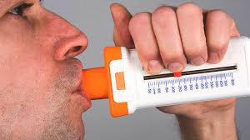 |  |  | References  Asthma.Foundation (2018) https://www.asthma.org.uk/globalassets/health-advice/.../your-peak-flow-diary.pdf  Health line (2019) https://www.healthline.com/health/peak-expiratory-flow-rate  NC State Extension Publications (2018) https://content.ces.ncsu.edu/asthma-and-allergies  Asthma Foundation Australia (2019) https://www.asthmaaustralia.org.au/.../VIC%20Schools%20Asthma%20Action%20Pla...

To take the test you will:  - Breathe in as deeply as you can.  - Blow into the mouthpiece as quickly and as hard as you can. Do not put your tongue in front of the mouthpiece.  - Do the test three times.  - Note the highest speed of the three.  If you cough or sneeze while breathing out, you will need to start again.  How often do I need to take the test?  To determine a “personal best,” you should measure your peak flow rate:  - at least twice a day for two to three weeks  - in the morning, upon awakening, and in the late afternoon or early evening  - 15 to 20 minutes after using an inhaled ventolin |  |  | 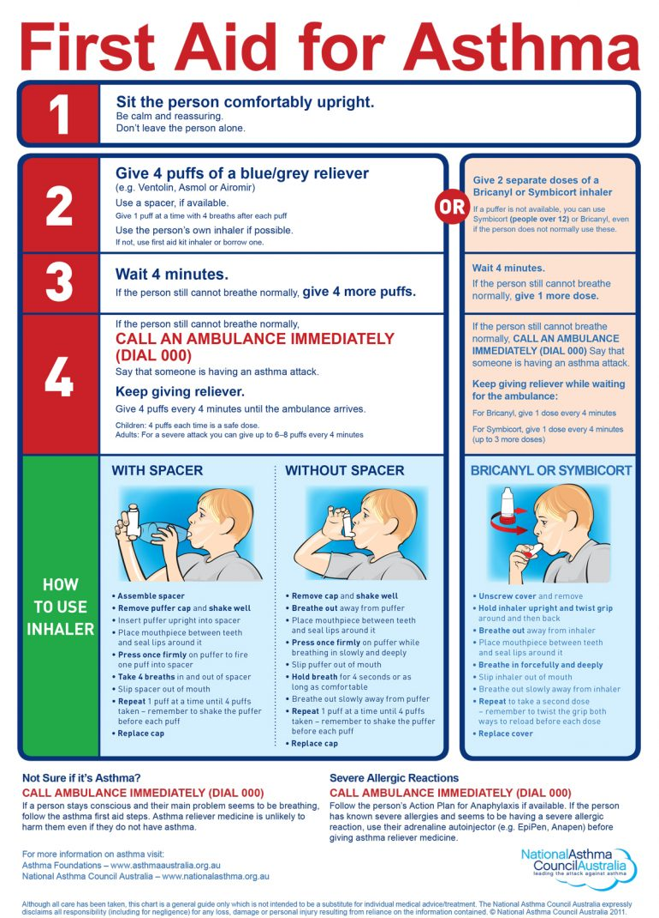  What do the numbers mean?  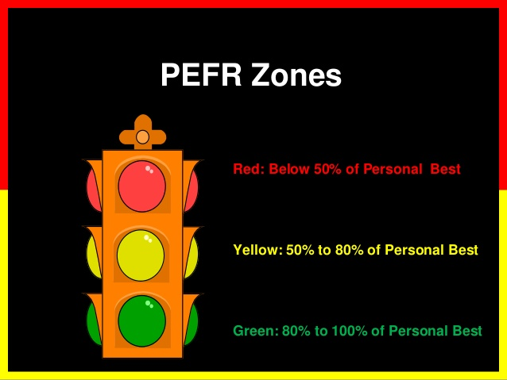  Green zone: 80 to 100 percent of your usual flow rate This is the ideal zone. It means your condition is under control.  Yellow zone: 50 to 80 percent of your usual flow rate Your airways may be starting to narrow. Talk to your doctor about how to handle yellow zone results.  Red zone: less than 50 percent of your normal rate Your airways are severely narrowing. Take your rescue medications and contact emergency services.

Asthma Action Plan
What to look out for

WHEN WELL
This means:
you have no night-time wheezing, coughing or chest tightness
• you only occasionally have wheezing, coughing or chest tightness during the day
• you need reliever medication only occasionally or before exercise
• you can do your usual activities without getting asthma symptoms

WHEN WELL | Asthma under control (almost no symptoms)
Always carry your reliever with you
Your preventer is (name & strength):– Use a spacer with your inhaler
Take: puffs times every day
Your reliever is (name):– Use a spacer with your inhaler
Take: puffs When you have symptoms like wheezing, coughing or shortness of breath
Other instructions: (e.g. other medicines, trigger avoidance, what to do before exercise)

WHEN NOT WELL
This means any one of these:
• you have night-time wheezing, coughing or chest tightness
• you have morning asthma symptoms when you wake up
• you need to take your reliever more than usual
• your asthma is interfering with your usual activities
THIS IS AN ASTHMA FLARE-UP

WHEN NOT WELL | Asthma getting worse (needing more reliever than usual, having more symptoms than usual, waking up with asthma, asthma is interfering with usual activities)

Keep taking preventer (name & strength):– Use a spacer with your inhaler
Take: puffs times every day
Your reliever is (name):– Use a spacer with your inhaler
Take: puffs

Contact your doctor

IF SYMPTOMS GET WORSE
This means:
• you have increasing wheezing, cough, chest tightness or shortness of breath
• you are waking often at night with asthma symptoms
• you need to use your reliever again within 3 hours
THIS IS A SEVERE ASTHMA ATTACK (SEVERE FLARE-UP)

IF SYMPTOMS GET WORSE | Severe asthma flare-up/attack (needing reliever again within 3 hours,  increasing difficulty breathing, waking often at night with asthma  symptoms)

Keep taking preventer (name & strength):– Use a spacer with your inhaler
Take: puffs times every day
Your reliever is (name):– Use a spacer with your inhaler
Take: puffs
Other instructions: (e.g. other medicines, when to stop taking extra medicines) Contact your doctor today
Prednisolone:
Take: each morning for days

DANGER SIGNS
This means:
• your symptoms get worse very quickly
• you have severe shortness of breath, can’t speak comfortably or lips look blue • you get little or no relief from your reliever inhaler

DANGER SIGNS | Asthma emergency (severe breathing problems, symptoms get worse  very quickly, reliever has little or no effect)

Call an ambulance immediately
Say that this is an asthma emergency Dial 000 for AMBULANCE
Keep taking reliever as often as needed
Use your adrenaline autoinjector (EpiPen)

Asthma Medicines
PREVENTERS
Your preventer medicine reduces inflammation, swelling and mucus in the airways of your lungs. Preventers need to be taken every day, even when you are well. Some preventer inhalers contain 2 medicines to help control your asthma (combination inhalers).

RELIEVERS
Your reliever medicine works quickly to make breathing easier by making the airways wider.
Always carry your reliever with you – it is essential for first aid. Do not use your preventer inhaler for quick relief of asthma symptoms unless your doctor has told you to do this.

2  https://www.asthma.org.uk/globalassets/health-advice/.../your-peak-flow-diary.pdf |  |  |  |  | 3
My NOTES, QUESTIONS and TASKS:
______________________________________________________________________________________________________________________________________________________________________________________________________________________________________________________________

Galway Medical Centre
267 Marion Road
MARLESTON SA 5033
Tel (work): (08) 8351 2211

