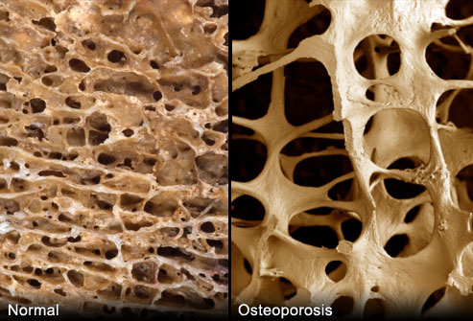
The Osteoporotic Bone

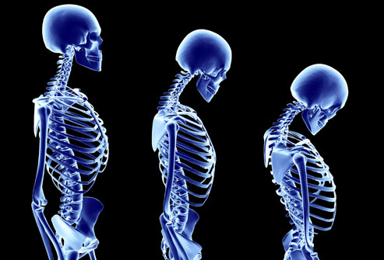
The Osteoporotic Posture

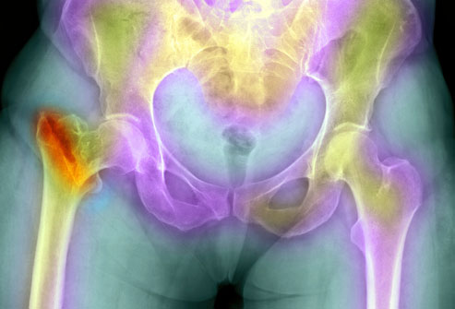Osteoporosis and Fractures
Osteoporosis is the underlying cause of 1.5 million fractures every year. Spinal compression fractures are the most common -- tiny fractures that can cause the vertebrae to collapse and alter the shape of the spine. Hip fractures can cause lasting mobility problems and even increase the risk of death. Wrist, pelvic, foot and other fractures are also common in people with osteoporosis.
Interesting Facts:
• Worldwide, 1 in 3 women over age 50 will experience osteoporotic fractures, as will 1 in 5 men aged over 50

• 80%, 75%, 70% and 58% of forearm, humerus, hip and spine fractures, respectively, occur in women. Overall, 61% of osteoporotic fractures occur in women, with a female-to-male ratio of 1.6

• Nearly 75% of hip, spine and distal forearm fractures occur among patients 65 years old or over

• A 10% loss of bone mass in the vertebrae can double the risk of vertebral fractures, and similarly, a 10% loss of bone mass in the hip can result in a 2.5 times greater risk of hip fracture
https://www.iofbonehealth.org/facts-statistics

What Causes Osteoporosis?
Our bones are constantly being rebuilt throughout our lifetime. Bones are made up of collagen, a protein that provides the basic framework, and calcium phosphate, a mineral that hardens the bone. As we age, we lose more bone than we replace. The greatest change in a woman's bone density comes in the five to seven years after menopause.
The green, oblong shape in the illustration is an osteoclast, a cell that breaks down bone.

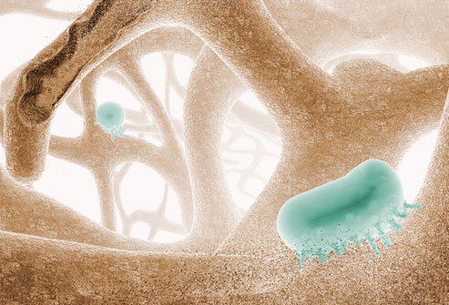

Risk Factors relating to Ethnicity & Diseases that we have no control over.
Women who are genetically predisposed to being thin and have a small frame are more likely to develop osteoporosis. Heredity plays a role, and so does ethnicity. It is more common among Caucasians and Asians, though other ethnic groups are still at risk, especially if they have other conditions, such as type 1 diabetes, rheumatoid arthritis, inflammatory bowel disease and hormonal disorders, which are also commonly linked to bone loss.

Risk Factors We Can Control
Smoking, an inactive lifestyle, and a diet low in calcium and vitamin D place individuals at greater risk for osteoporosis. Excess drinking is linked to bone loss and a risk of fractures. Corticosteroids, anti-inflammatory drugs used to treat asthma and other conditions, increase your risk of bone loss. Eating disorders (anorexia nervosa or bulimia), gastric or weight loss surgery like a sleeve or a gastric by-pass can also take a toll on bone health.
Modifiable and lifestyle factors list
- Premature menopause
- Hypogonadism
- Multiple falls
- Low physical activity or immobility
- Low body weight secondary to inadequate intake
- Low muscle mass and strength
- Poor balance
- Protein or calcium undernutrition
- Smoking
- Alcohol >2 standard drinks/day
- Vitamin D insufficiency

Diseases or conditions list
- Rheumatoid arthritis
- Hyperthyroidism
- Hyperparathyroidism
- Chronic kidney disease
- Chronic liver disease
- Coeliac disease or malabsorption
- Diabetes mellitus
- Myeloma or MGUS
- Organ transplant
- Bone marrow transplant
- HIV infection
- Depression

Medications (large effect)
- Glucocorticoids (>3 months≥7.5 mg/day) e.g. hydrocortisone (Cortef) cortisone ethamethasoneb, (Celestone), prednisone (Prednisone Intensol)
- Excess thyroid hormone replacement
- Aromatase inhibitors (Breast cancer meds: Anastrozole (Arimidex), Exemestane (Aromasin), Letrozole (Femara)
- Anti-androgen therapy
Medications (modest effect)
- SSRIs
- Anti-psychotics
- Thiazolidenediones (Diabetic meds: Pioglitazone (Actos), Rosiglitazone (Avandia)
- Anti-epileptic medications
- PPIs (reflux medications)

Do Men Get Osteoporosis?
Osteoporosis is much more common in women, but men are at risk, too. In fact, about 25% of men over 50 will have an osteoporosis-related fracture. Osteoporosis may be under-diagnosed in men because it is often considered a "woman's disease" and men may not be tested.

TESTS
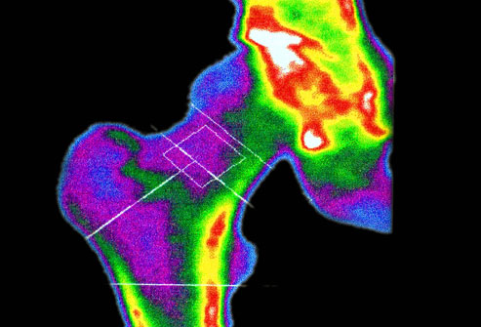

DXA Bone Density Scan
Your doctor may recommend a bone mineral density test if:
- You're over 50 and have broken a bone
- You are a woman over 65, or a man over 70
- You are in menopause or past menopause and have risk factors
- You are a man age 50-69 with risk factors
DXA (dual X-ray absorptiometry) uses low-dose X-rays to measure bone density in the hip and spine. The test takes less than 15 minutes.

Testing: What Your T-Score Means
Testing compares your bone mineral density (BMD) with that of a healthy 30-year-old, since that's when bone mass is at its peak. The results come as a T-score in these ranges:
- -1.0 and higher is normal bone density
- Between -1.0 and -2.5 shows low bone density (osteopenia) but not osteoporosis
- -2.5 or below indicates osteoporosis
As your bone density decreases, your T-score gets lower.
For those older than 50 years of age with a minimal trauma fracture of the hip or spine, osteoporosis treatment can be initiated without confirmation of low bone mineral density (BMD).

Treatment: Bone-Boosting Drugs
If you are diagnosed with osteoporosis, you may be prescribed a biophosphonate: Actonel, Boniva, Fosamax, or Reclast. They can reduce bone loss and fracture risk and may actually help build some bone density. Those taken by mouth can cause gastrointestinal problems such as ulcers in the esophagus, acid reflux, and nausea. Injectable bisphosphonates, given one to four times a year, can cause brief flu-like symptoms. Bisphosphonates may increase risk of jaw bone destruction and atypical femur fractures.

Treatment: Estrogen Agents
Hormone replacement therapy, once used widely for menopause symptoms, is an option for osteoporosis in women who have menopausal symptoms, but it's used less than other medications because of concerns about the risk of cancer, blood clots, heart disease, and stroke. Evista is not a hormone but can provide similar bone-strengthening effects to estrogen without the cancer risks. Risks include blood clots and increased hot flashes. Forteo, a synthetic parathyroid hormone, requires daily injections and actually builds new bone. Leg cramps and dizziness have been reported with Forteo use.

Treatment: A Biologic Alternative
Prolia is a lab-produced antibody that slows the breakdown of bone. Given as an injection twice a year, it is for postmenopausal women at high risk for fractures who can't tolerate other osteoporosis drugs or who haven't been helped by other drugs. Rare and infrequent side effects can include back pain, muscle pain, bone pain, a higher risk of infections, constipation and lower calcium levels (especially where kidney conditions are present also). Since Prolia may lower the calcium levels in your blood, if you have low blood calcium, it may get worse during treatment. Your low blood calcium must be treated before you receive Prolia. You may need to take calcium and vitamin D to help prevent low blood calcium.

Supplements for Healthy Bones
Boys aged 9 to 13 years, girls aged 9 to 18 years, women older than 50 years and men older than 70 years may require more calcium than they get in their regular diet. Two types of calcium supplements are commonly available: calcium carbonate and calcium citrate, which are equally beneficial. Splitting your dose -- taking half in the morning and half later in the day -- improves absorption. Check with a doctor about the upper limit for calcium. Too much can lead to kidney stones. Getting adequate vitamin D aids the absorption of calcium.

Foods That Are Bad to the Bone
Some foods can sap your body's calcium. Minimize salty foods such as canned soups and processed meats. Most Americans get much more sodium than they need. Caffeine can decrease your body's absorption of calcium, but the effect is minimal unless you drink more than three cups of coffee a day. Heavy alcohol use can also lead to bone loss.
Which Foods Have the Most Calcium?
Drinking a glass of vitamin D-fortified milk is one of the best ways to get your calcium. Other dairy products vary in their calcium content. Yogurt and cheese are better choices than ice cream or frozen yogurt. Fish, such as sardines and salmon, are good sources. Fortified foods, such as cereals and orange juice, can also provide a lot of calcium.
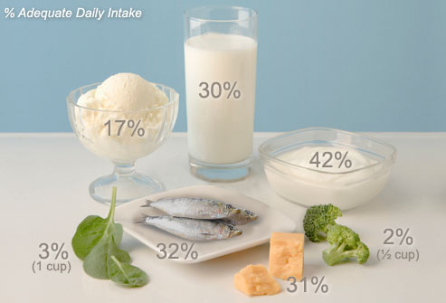

Bone-Building Foods
Eating calcium-rich foods can help protect your bones no matter what your age. You need the equivalent of about three and a half 8-ounce glasses of milk a day. Fish such as salmon, tuna, and herring also contain vitamin D, which helps us absorb calcium, and leafy green vegetables also provide magnesium, which helps maintain good bone quality. Some foods and drinks are also fortified with calcium and vitamin D.
Here are the recommended daily intakes for calcium by age: Under 1 year: 200-260 mg
1-3 years: 700 mg, 4-8 years: 1,000 mg, 9-18 years: 1,300 mg, 19-50 years : 1,000 mg
51-70 men: 1,000 mg, 51+ women: 1,200 mg, 71+ years: 1,200 mg (see Appendix A for list of foods high in calcium & their mg content)
Non-Dairy Calcium sources
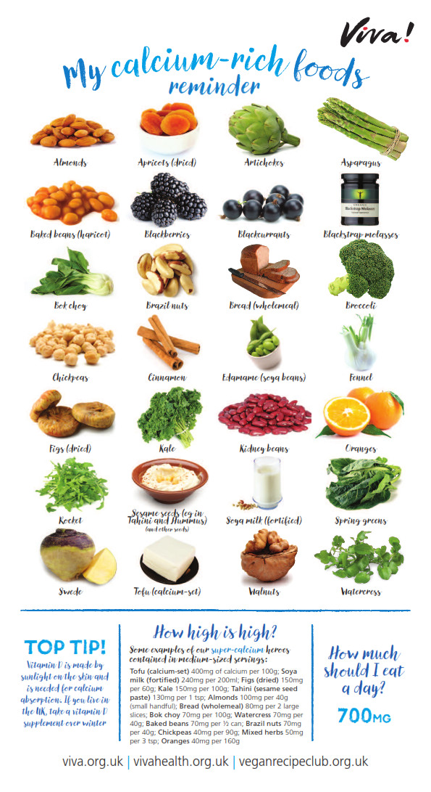

Strong Muscles make Strong Bones
Weight-bearing exercise can help you build bone and maintain it. That includes walking, jogging, tennis, and other activities where you move the full weight of your body. Using small weights in many different activities helps bones. Women who walk just a mile a day have four to seven more years of bone reserve, researchers have found.
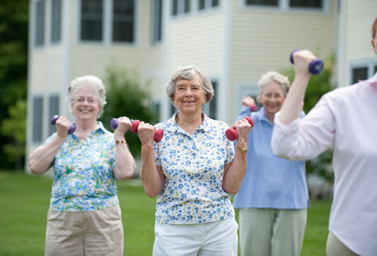

Exercise Caution
While yoga and Pilates can help with balance, too much twisting or forward-bending can increase the risk of spinal compression fractures in people who have osteoporosis. High-impact activities also can be risky for people with low bone density. Swimming and bicycling can be great exercise, but they are not weight-bearing and therefore not as effective in providing bone-health benefits.

Preventing Falls: The Basics - Avoiding fractures is also key to keeping your bones healthy, whether you have bone loss or not. To prevent a fall that could cause a fracture, minimize clutter and be sure that your area rugs are anchored to the floor. Eliminate throw rugs and loose cords. Wearing sturdy, rubber-soled shoes also can reduce the risk of falling.

It's Never Too Late for Bone Health - Many people don't find out about their bone loss until they are in their 60s or older. But you can still benefit from boosting a low calcium intake to recommended levels and exercising regularly. Exercises such as tai chi improve balance, which can help prevent falls.

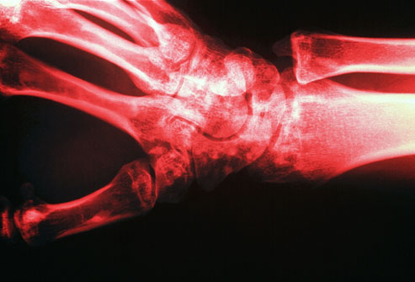
Osteopenia: Borderline Bone Loss
If you have bone loss but not enough to be osteoporosis, you may have a condition called osteopenia. As with osteoporosis, there are no physical symptoms. Osteopenia can progress to osteoporosis, but with changes in diet and exercise, you can slow the bone loss. Your doctor will evaluate you to see if you need medication.

Can Osteoporosis Be Reversed?

Most medications for osteoporosis reduce bone loss or slightly increase bone density. Forteo helps build new bone, but requires daily injections and can only be used for two years because of potential side effects. But there's a glimmer of hope for a cure for osteoporosis. New research in animals indicates that an experimental drug that blocks serotonin from being synthesized in the gut could actually build new bone and reverse bone loss.

Build Bones in Your Youth

Healthy habits as a child or teenager can pay off years later with stronger bones. Young people can build their bones by eating calcium-rich foods, getting enough vitamin D (through sunshine or diet), and exercising regularly. By age 30, the average woman has built 98% of her peak bone mass.
References - Web sources:
https://www.webmd.com/osteoporosis/ss/slideshow-osteoporosis-overview

https://www.osteoporosis.org.au/sites/default/files/files/calcium-food-table-web.pdf
https://www.vivahealth.org.uk/resources/calcium-rich-foods-wallchart https://www.racgp.org.au/clinical-resources/clinical-guidelines/key-racgp-guidelines/view-all-racgp-guidelines/osteoporosis

